Lesson #3: IMPERIAL MEASUREMENT
2.54cm = 1" (1in)
12" = 1' (1ft)
~30cm = 1ft
1ft = 3 yards
1760 yards = 1 mile
This could go on forever….
LET'S BREAK DOWN AN INCH: LABEL ALL THE INCREMENTS IN THIS INCH.

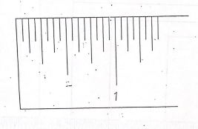

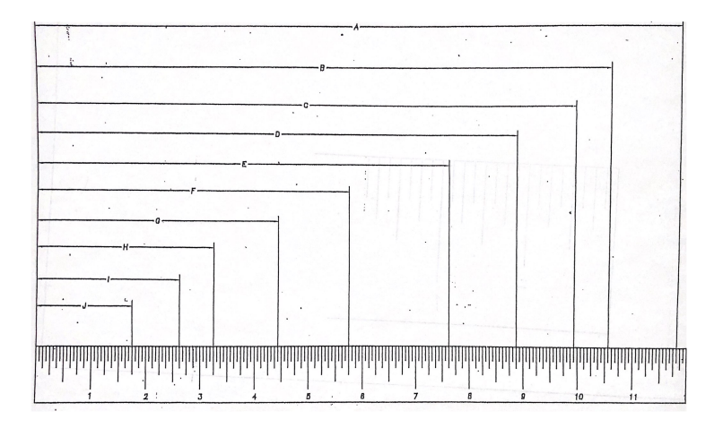
USING THE RULER PROVIDED, MEASURE EACH OF THE FOLLOWING DISTANCES:
YOU MAY HAVE TO PRINT THIS OUR TO READ IT BETTER.

A:

B:

C:

D:

E:

F:

G:

H:

I:

J:

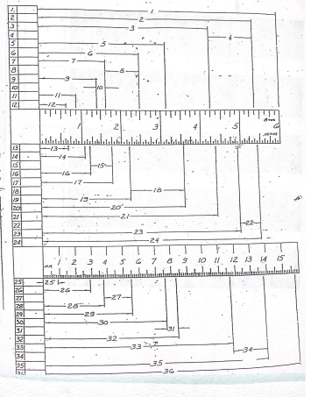
MEASURE THESE LINES: #1-24 IN INCHES AND #25-36 IN MM. REMEMBER TO SIMPLIFY.

MEASURING AT HOME ASSIGNMENT
Name: ____________________________ Date: _____________________

Measure these things around your house to the nearest 1/16" of an inch. Use a tape measure!!!!

- Your height: (this is easy with your back against the wall. Maybe with someone assisting you)

- The height of your kitchen cabinets:

- The space between kitchen cabinets that accommodates your oven/stove:

- The width of the door to your bedroom (interior door):

- The width of the EXTERIOR front door to your house:

- Is the width of the interior door and exterior the same? Explain why you think why or why not:

- The length of a bathtub in your house:

- The height of your cabinets in your bathroom: (this is called a vanity)

- Is the height you your kitchen cabinets and vanity cabinets the same? Are the depths the same?

- With your cover off, measure the length, width and height of your phone. What kind/model of phone is it?

Great work! All these measurements will be used to 3D model parts or design a house!!

