Lesson #2 PRACTICE Orthographic drawings WORKSHEETS
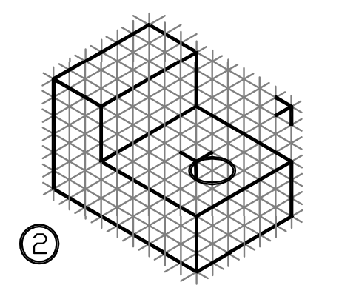
#2
PRINT THIS SHEET OUT!!
NAME: ______________________
Using a ruler, complete the Orthographic Drawings of the picture to the left. Once block on the example = one block on your graph paper. Include all three views (FRONT, TOP, RIGHT SIDE). Include all necessary line types (OBJECT, HIDDEN, CENTER, PROJECTION, MITER). Attach a picture of this drawing to your assignment

Lesson #2 PRACTICE Orthographic drawings WORKSHEETS
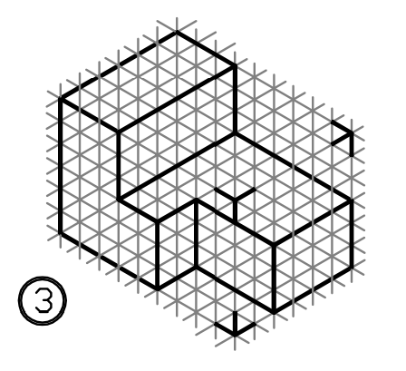
#3
PRINT THIS SHEET OUT!!
NAME: ______________________
Using a ruler, complete the Orthographic Drawings of the picture to the left. Once block on the example = one block on your graph paper. Include all three views (FRONT, TOP, RIGHT SIDE). Include all necessary line types (OBJECT, HIDDEN, CENTER, PROJECTION, MITER). Attach a picture of this drawing to your assignment

Lesson #2 PRACTICE Orthographic drawings WORKSHEETS
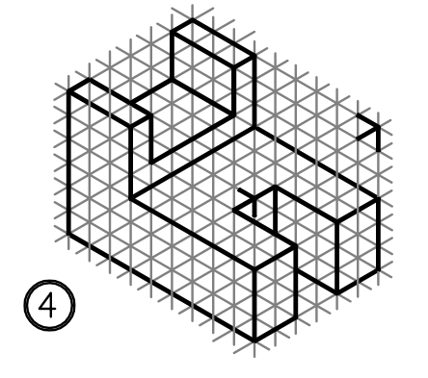
#4
PRINT THIS SHEET OUT!!
NAME: ______________________
Using a ruler, complete the Orthographic Drawings of the picture to the left. Once block on the example = one block on your graph paper. Include all three views (FRONT, TOP, RIGHT SIDE). Include all necessary line types (OBJECT, HIDDEN, CENTER, PROJECTION, MITER). Attach a picture of this drawing to your assignment

Lesson #2 PRACTICE Orthographic drawings WORKSHEETS
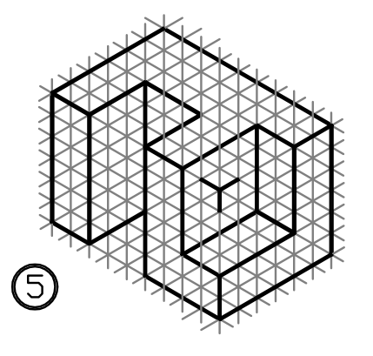
#5
PRINT THIS SHEET OUT!!
NAME: ______________________
Using a ruler, complete the Orthographic Drawings of the picture to the left. Once block on the example = one block on your graph paper. Include all three views (FRONT, TOP, RIGHT SIDE). Include all necessary line types (OBJECT, HIDDEN, CENTER, PROJECTION, MITER). Attach a picture of this drawing to your assignment

Lesson #2 PRACTICE Orthographic drawings WORKSHEETS
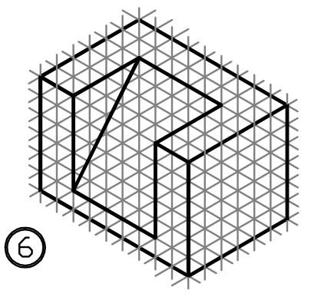
#6
PRINT THIS SHEET OUT!!
NAME: ______________________
Using a ruler, complete the Orthographic Drawings of the picture to the left. Once block on the example = one block on your graph paper. Include all three views (FRONT, TOP, RIGHT SIDE). Include all necessary line types (OBJECT, HIDDEN, CENTER, PROJECTION, MITER). Attach a picture of this drawing to your assignment

Lesson #2 PRACTICE Orthographic drawings WORKSHEETS
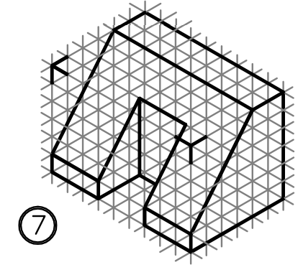
#7
PRINT THIS SHEET OUT!!
NAME: ______________________
Using a ruler, complete the Orthographic Drawings of the picture to the left. Once block on the example = one block on your graph paper. Include all three views (FRONT, TOP, RIGHT SIDE). Include all necessary line types (OBJECT, HIDDEN, CENTER, PROJECTION, MITER). Attach a picture of this drawing to your assignment

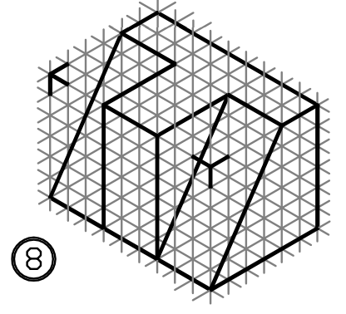
Lesson #2 PRACTICE Orthographic drawings WORKSHEETS
#8
PRINT THIS SHEET OUT!!
NAME: ______________________
Using a ruler, complete the Orthographic Drawings of the picture to the left. Once block on the example = one block on your graph paper. Include all three views (FRONT, TOP, RIGHT SIDE). Include all necessary line types (OBJECT, HIDDEN, CENTER, PROJECTION, MITER). Attach a picture of this drawing to your assignment

Lesson #2 PRACTICE Orthographic drawings WORKSHEETS
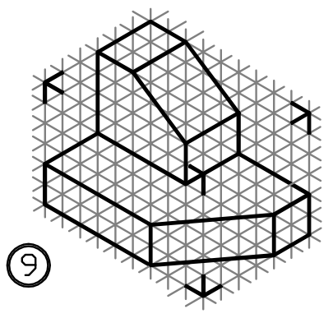
#9
PRINT THIS SHEET OUT!!
NAME: ______________________
Using a ruler, complete the Orthographic Drawings of the picture to the left. Once block on the example = one block on your graph paper. Include all three views (FRONT, TOP, RIGHT SIDE). Include all necessary line types (OBJECT, HIDDEN, CENTER, PROJECTION, MITER). Attach a picture of this drawing to your assignment

Lesson #2 PRACTICE Orthographic drawings WORKSHEETS
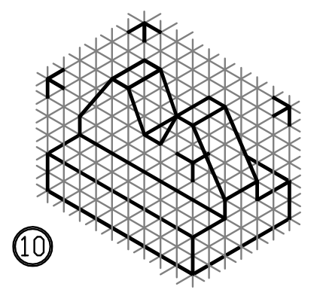
#10
PRINT THIS SHEET OUT!!
NAME: ______________________
Using a ruler, complete the Orthographic Drawings of the picture to the left. Once block on the example = one block on your graph paper. Include all three views (FRONT, TOP, RIGHT SIDE). Include all necessary line types (OBJECT, HIDDEN, CENTER, PROJECTION, MITER). Attach a picture of this drawing to your assignment

Lesson #2 PRACTICE Orthographic drawings WORKSHEETS
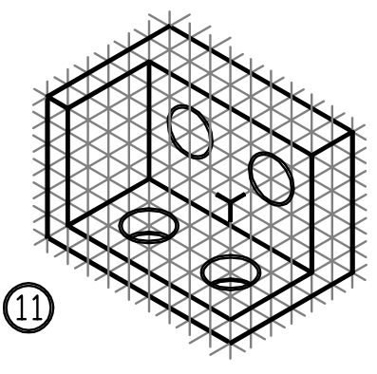
#11
PRINT THIS SHEET OUT!!
NAME: ______________________
Using a ruler, complete the Orthographic Drawings of the picture to the left. Once block on the example = one block on your graph paper. Include all three views (FRONT, TOP, RIGHT SIDE). Include all necessary line types (OBJECT, HIDDEN, CENTER, PROJECTION, MITER). Attach a picture of this drawing to your assignment

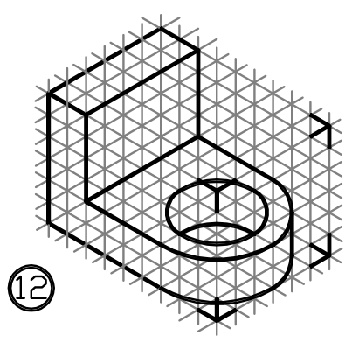
Lesson #2 PRACTICE Orthographic drawings WORKSHEETS
#12
PRINT THIS SHEET OUT!!
NAME: ______________________
Using a ruler, complete the Orthographic Drawings of the picture to the left. Once block on the example = one block on your graph paper. Include all three views (FRONT, TOP, RIGHT SIDE). Include all necessary line types (OBJECT, HIDDEN, CENTER, PROJECTION, MITER). Attach a picture of this drawing to your assignment

