Lesson #2 Orthographic drawings

Orthographic projection drawing is a means of representing three-dimensional objects in two dimensions. These views provide the most accurate representation for designers/developers and allow for the drawing to be easily dimensioned.
- Usually has 3 views: FRONT, TOP, SIDE (Can have more views if part is very detailed)
- The front view is the "MAIN VIEW" and gives the most information about its shape. All other views are referenced off the main front view.
- Choose views to show the most visible lines and avoid excessive use of "hidden" lines.

- All views line up parallel
- Gap distance between each view is relatively the same
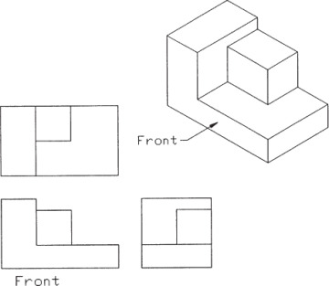
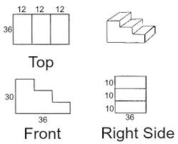

The Miter Line and Projection Lines

• The use of a 45° miter line and Projection Lines provide a quick, accurate method of drawing the other views once one view is completed. Sometimes you will need to work on separate views and project lines to each other to fully complete any view.
• Newbie drafters will sometimes try to avoid using the miter line, but as the drawings become more difficult their work will slow down and the accuracy will diminish.
• Once the miter line technique is mastered your speed and accuracy will increase significantly.
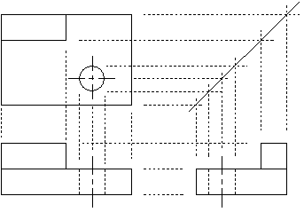
• Note: When drawing circles always draw the view with the circle on it first (top view on drawing below) then project the lines to the other views.

Views must lineup!
• The worst mistake you can make in technical drawing is to draw the views out of place. The last 2 drawings would need to be redone or reworked.

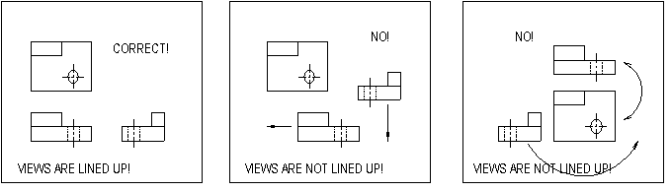
Three main line types:
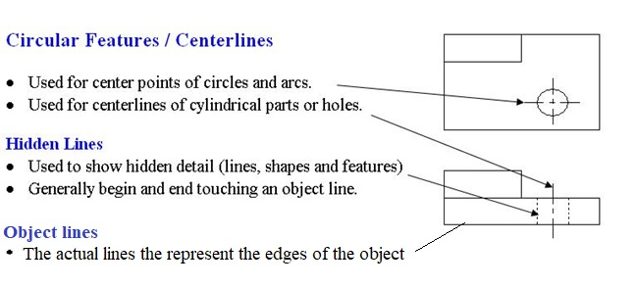

.

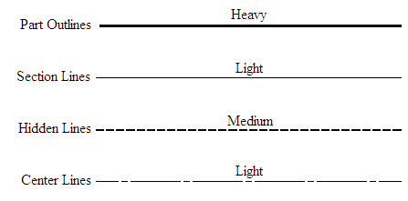
Last week's example solved:

